Regression modal information

Type of modal used: Linear regression modal

Prediction was made for 2 years and graphical result were made to display results

Mathematically   
The simple linear regression model assumes that there is a linear relationship between the independent variable (X) and the dependent variable (Y). Mathematically, this relationship is represented as:

Y = β0 + β1X + ε

Where:

Y is the dependent variable.

X is the independent variable.

β0 is the intercept (the value of Y when X is 0).

β1 is the slope (the change in Y for a one-unit change in X).

ε is the error term, representing the unexplained variation in Y that is not accounted for by the linear relationship.

Report

Summary of findings



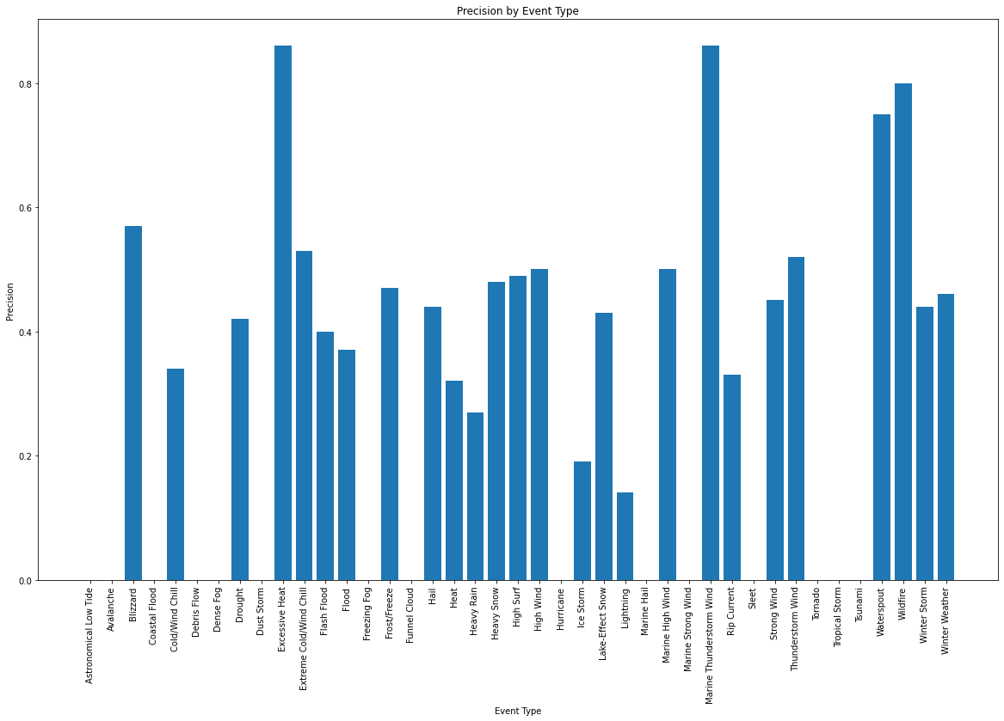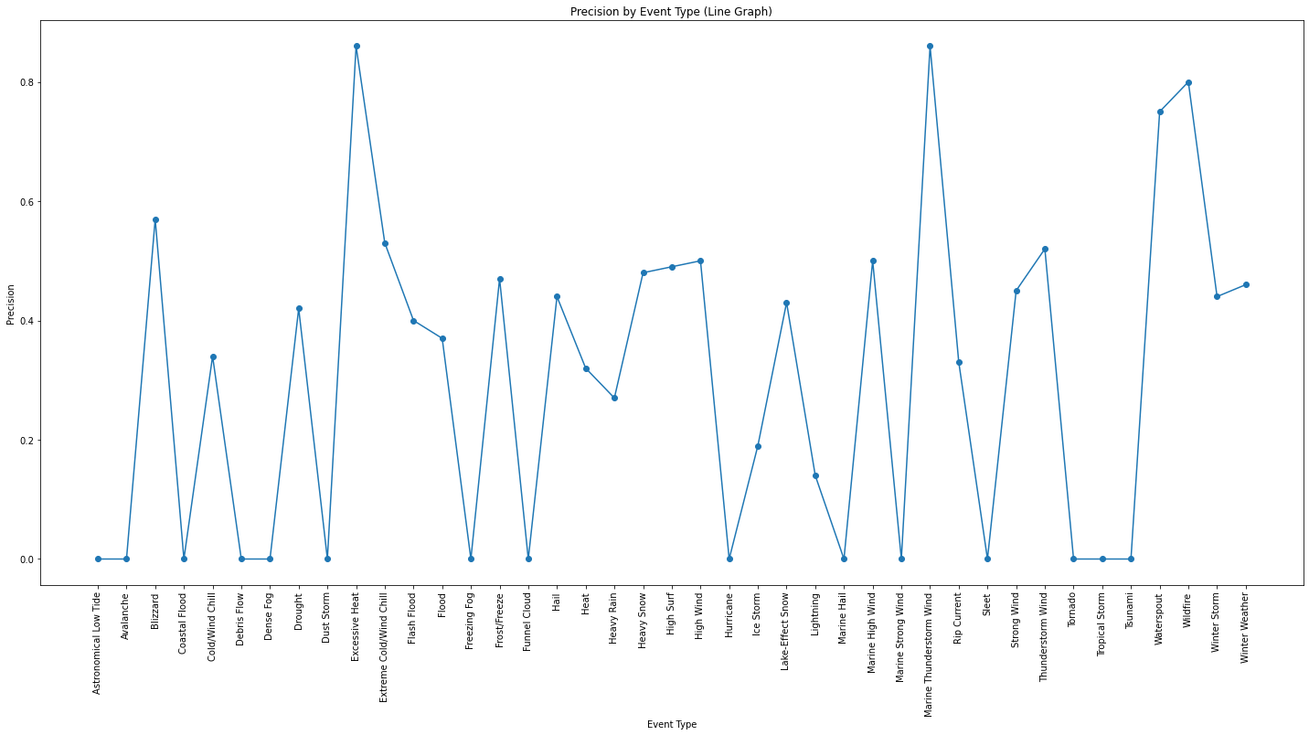

From the report it is seen that Excessive Heat and Thunderstorm are more likely to happen more frequently within the time frame of 2 years

The accuracy of the findings is been tabulates below

|  |  |  |  |  |
| --- | --- | --- | --- | --- |
| accuracy |  |  | 0.47 | 10235 |
| macro avg | 0.3 | 0.24 | 0.24 | 10235 |
| weighted avg | 0.44 | 0.47 | 0.44 | 10235 |